CL1002 INTRODUCTION TO COMPUTING | LAB 06  2D ARRAYS IN C

TWO-DIMENSIONAL ARRAYS

A two-dimensional array is a collection of a fixed number of components arranged in rows and columns (that is, in two dimensions), wherein all components are of the same type.
Two-dimensional arrays are used to represent tables of data, matrices, and other two-dimensional objects.

SYNTAX:
element-type aname [ size₁ ] [ size₂ ]; /* uninitialized */

INTERPRETETION
- Allocates storage for a two-dimensional array ( aname ) with size1 rows and size2 columns.
- This array has size1*size2 elements, each of which must be referenced by specifying a row subscript ( 0 , 1 ,… size1-1 ) and a column subscript ( 0 , 1 ,…size2-1 ).
- Each array element contains a character value.

MEMORY REPRESENTATION
char x[ 3 ][ 3 ] = {{‘X’, ‘0’, ‘X’}, {‘0’, ‘X’, ‘0’}, {‘0’, ‘X’, ‘X’}};

Array x
Column
Row
 | 0 | 1 | 2
0 | x[0][0] | x[0][1] | x[0][2]
1 | x[1][0] | x[1][1] | x[1][2]
2 | x[2][0] | x[2][1] | x[2][2]
Column

Row | 0 | 1 | 2
0 | X | O | X
1 | O | X | O  x[ 1 ][ 2 ]
2 | O | X | X

Because memory is addressed linearly, a better representation is like:
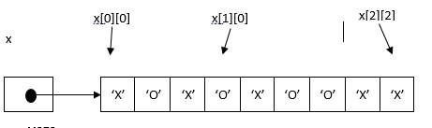

USES
- Storing a table of data (not the only way).
- Any kind of matrix processing, as a 2D array really is a matrix.
Example 01:
#include<stdio.h>
int main(){
/* 2D array declaration*/
int array[3][3];
/*Counter variables for the loop*/
int i, j;
for(i=0; i<3; i++) {
for(j=0;j<3;j++) {
printf("Enter value for array[%d][%d]:", i, j);
scanf("%d", &array[i][j]);
}
}
//Displaying array elements
printf("Two Dimensional array elements:\n");
for(i=0; i<3; i++) {
for(j=0;j<3;j++) {
printf("%d ", array[i][j]);
if(j==2){
printf("\n");
}
}
}
return 0;
}
Output:
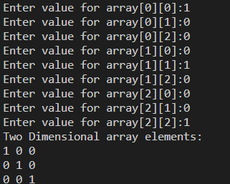

MULTIDIMENSIONAL ARRAYS

Multidimensional array is a collection of a fixed number of elements (called components) arranged in n dimensions (n>=1).

SYNTAX:

element-type aname [ size 1 ] [ size 2 ] … [ size n ]; /* storage allocation */

INTERPRETATION:
- Allocates storage space for an array aname consisting of size 1 × size 2 × … × size n memory cells.
- Each memory cell can store one data item whose data type is specified by element-type . The individual array elements are referenced by the subscripted variables aname [0][0] … [0] through aname [ size 1 −1][ size 2 −1] …[ size n −1] .
- An integer constant expression is used to specify each size i .

USES
With input data on temperatures referenced by day, city, county, and state, day would be the first dimension, city would be the second dimension, county would be the third dimension, and state would be the fourth dimension of the array. In any case, any temperature could be found as long as the day, the city, the county, and the state are known. A multidimensional array allows the programmer to use one array for all the data.

Example:
#include <stdio.h>

int main(void)
{
// initializing the 3-dimensional array
int x[2][3][2] = { { { 0, 1 }, { 2, 3 }, { 4, 5 } },
{ { 6, 7 }, { 8, 9 }, { 10, 11 } } };

// output each element's value
for (int i = 0; i < 2; ++i) {
for (int j = 0; j < 3; ++j) {
for (int k = 0; k < 2; ++k) {
printf("Element at x[%i][%i][%i] = %d\n", i, j, k, x[i][j][k]);
}
}
}
return (0);
}

Output:
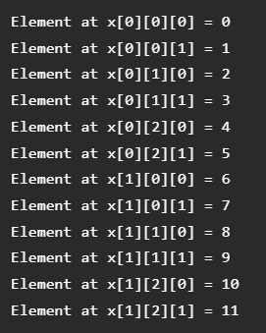

Exercises

- An instructor has 5 students in her class. Each student is identified by a number from 1 to 5 ,3 Subjects have been assigned to instructor. Marks are stored in a 2 dimensional array where row represent no of student and column represent no of subjects . The instructor would like to enter a student’s test score printed on the monitor. Develop a program to output the needed information, find highest average and minimum number of each student and also average of all students per subject.

- Given an array arr[] of size N*M which contains elements from 0 to N-1*M-1, you need to find all the elements occurring more than once in the 2D array.

- Fast University has X Department and each Department has Y faculty. Write a program that enters faculty information for each faculty - FacultyID,age and salary of each department. Do print the faculty information which includes Department# FacultyID, salary, age. After all faculty information entries, do print ID of the faculty who has lowest salary, age of the faculty with highest salary and department# with highest total salary of faculty.

- Write a program that repeatedly asks user about creating new accounts for a bank. Every time user can respond in three ways, Y, N or E. If Y, then input IDs, initial balance and validity in days. If N, then print a message “I will ask again”, and again ask for user preference. If E, then exit the repetition. Before program ends, you are required to print all ID, all balances and their validity in a tabular form. At the end of the table, do print total IDs count, total balance, and minimum validity.

- A hybrid vehicle needs a program that keeps track of the fuel usage and battery usage. This program runs indefinitely and stores information for all travels. In each travel, the program asks about KM driven under 40 KM/h speeds, KM driven over 40 KM/h speed. Assuming that the vehicle uses 1 L for 15 KM and 1 full battery for 30 KM. Calculate the total cost of all travels if 1 L is bought at the rate of XYZ rupees (XYZ is first three digits of your ID). Every time user enters the details, print total KM driven so far, the total cost of the fuel and number of times battery completely used.

- Write a program to copy the content of 2D array into another in reverse order.

- Write a C Program to find the trace of a matrix. Trace of a nxn matrix is sum of diagonal elements. Give a square matrix we have to find the trace of the matrix
Input:
Matrix:
9 8 7
5 4 6
1 2 3

Output:
Trace of matrix is: 16

- Given a matrix Write a C program which takes row numbers from the user and interchange them at the specified rows provided by the user.
Input:
Matrix before row exchange:
1 2 3
4 5 6
7 8 9
Enter two row numbers to be exchanged:1 3
Output:
Matrix after row exchange:
7 8 9
4 5 6
1 2 3

